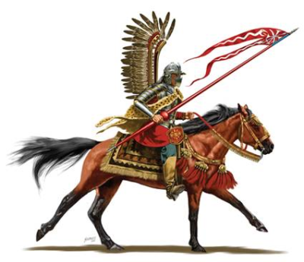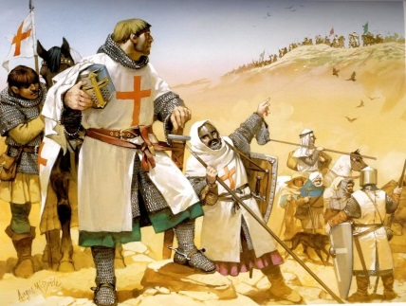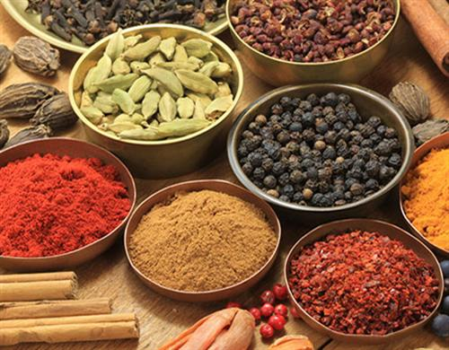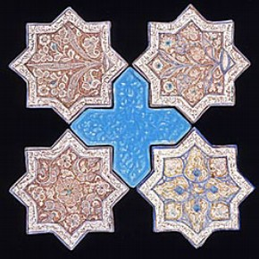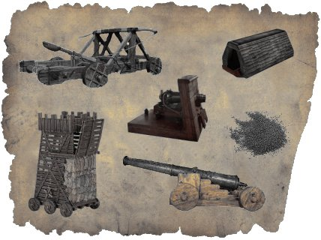

**CARD I: Muslim Counter Attack**

Rather than defeating the Muslims, the Crusades provoked a Muslim backlash. In 1453, the Turks captured Constantinople and by 1529 they even threatened Vienna in Austria.

**CARD H: Muslim Culture**

Not all the Crusaders went home after fighting the Muslims. Many of them who went to the Holy Land liked it so much that they stayed and adopted a Middle Eastern way of life, including using bathhouses and soap.

**CARD G: Exotic Products**

Western Europeans learned about many things they had never seen before e.g. lemons, apricots, sugar, silk, cotton and spices used in cooking.

**CARD F: Maths, Science and Medicine**

The Crusaders learned about Maths, Science and Medicine from Muslim scholars.

**CARD E: Military Significance**

The Crusaders learned more about warfare – better castle design and even gunpowder.